Project Evolve
System - Atradius Experience

User Interface Design Specification

Dec 14, 2015
Ver 0.6a

In association with:

Document History

Version | Change Description | Author | Date Released
0.1 | Initial Document | Infosys | 05/05/2004
0.2 | Modified to fit Atradius Experience, added details for risk screen | Jonathan Elsen | 25/11/2015
0.3 | Add ranking page documentation | Jonathan Elsen | 26/11/2015
0.4 | Added login and wrapper screens | Emanuel | 27/11/2015
0.5 | Added company page | Jonathan Elsen | 09/12/2015
0.6 | Added market page (client side) (‘Global’section aka Big Prospects) | Emanuel de Graaff | 17/12/2015
0.6a | Added some remarks based on dev team queries; updated making an offer, risk score and mini dashboard | Emanuel | 06/01/2016

Table of Contents
1 Wrapper 5
1.1 Description 5
1.2 Screen Layout 5
1.3 Screen Element Specification 7
1.4 Validation, Business Rules, Dynamic Specifications 7
1.5 Pop Ups (avatar) 8
1.6 Pull Downs 9
1.7 Warnings and Exceptions 11
1.8 Issues 12
2 Login screen 13
2.1 Description 13
2.2 Screen Layout 13
2.3 Screen Element Specification 14
2.4 Validation, Business Rules, Dynamic Specifications 14
2.5 Warnings and Exceptions 14
3 Risk screen 15
3.1 Description 15
3.2 Screen Layout 15
3.3 Screen Element Specification 16
3.4 Validation, Business Rules, Dynamic Specifications 17
3.5 Tab Order 18
3.6 Pop Ups 19
3.7 Pull Downs 19
3.8 Warnings and Exceptions 19
3.9 Issues 19
4 Ranking screen 20
4.1 Description 20
4.2 Screen Layout 20
4.3 Screen Element Specification 21
4.4 Validation, Business Rules, Dynamic Specifications 21
4.5 Tab Order 21
4.6 Pop Ups 22
4.7 Pull Downs 22
4.8 Warnings and Exceptions 22
4.9 Issues 22
5 Company screen 23
5.1 Description 23
5.2 Screen Layout 23
5.3 Screen Element Specification 26
5.4 Validation, Business Rules, Dynamic Specifications 27
5.5 Tab Order 27
5.6 Pop Ups 27
5.7 Pull Downs 27
5.8 Warnings and Exceptions 28
5.9 Issues 28
6 Market screen 29
6.1 Description 29
6.2 Screen Layout 29
6.3 Screen Element Specification 31
6.4 Validation, Business Rules, Dynamic Specifications 33
6.5 Tab Order 35
6.6 Pop Ups 35
6.7 Pull Downs 35
6.8 Warnings and Exceptions 35
6.9 Issues 35
7 Appendix 36

Wrapper

Description
This screen functions as a content wrapper. It includes the navigation menu and additional user features such as loggin out, displaying team info and (mini) dashboard to indicate team performance.

Screen Layout
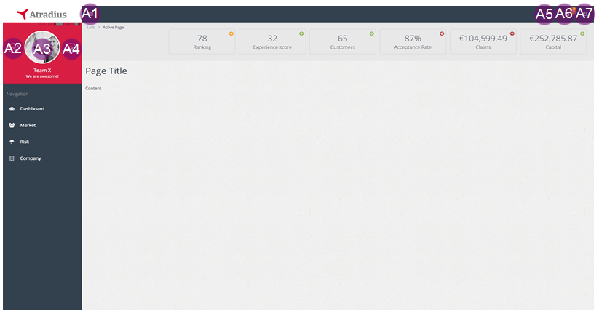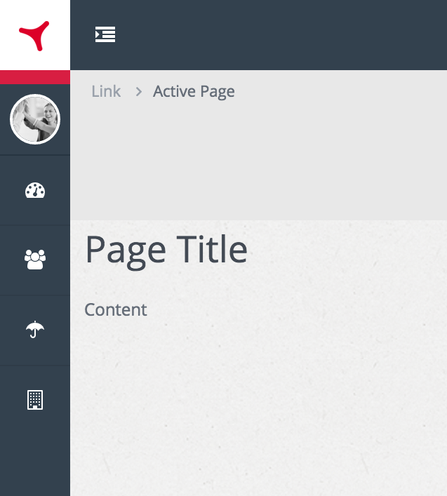
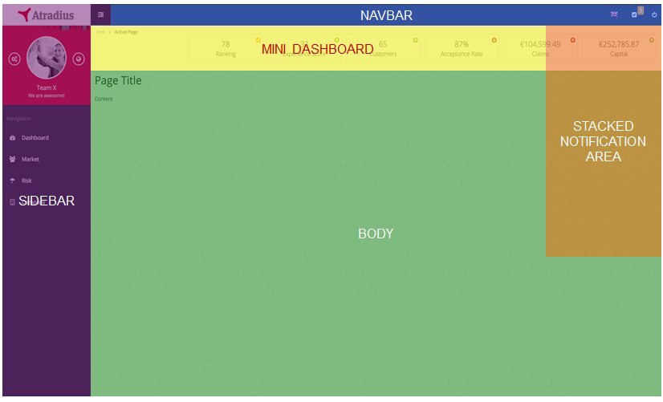
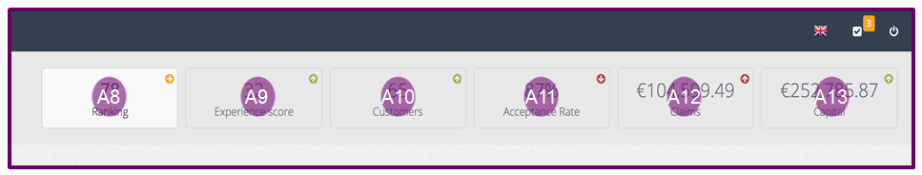

Screen Element Specification
Ele ID# | Dynamic/Static | Element Name | Element Type | Default State | Action | Response/ Notes
Block A – short description
A1 | Dynamic | collapseSidebar | Hyperlink | Disabled | Collapse entire sidebar towards the left with CSS/Javascript on the front-end | Images like logo and avatar need to be made smaller as the sidebar will remain visible
A2 | Dynamic | /settings | Hyperlink | Disabled | Loads ‘settings’ content | None
A3 | Dynamic | uploadAvatar | Hyperlink | Disabled | Opens OS selection window | After image selection, the image is displayed immediately in the avatar position after upload
A4 | Dynamic | /ranking | Hyperlink | Disabled | Loads ‘ranking’ content | None

Validation, Business Rules, Dynamic Specifications
ID# | Event | Business logic
A1 | OnClick | None
A2 | OnClick | Ui-router redraws BODY with the ‘settings’ content
A3 | OnClick | Open OS file selection window, after submit upload the image to the server and store it in the ‘team’ collection. Then load it in the avatar placeholder.
A4 | OnClick | Ui-router redraws BODY with the ‘ranking’ content

ID# | Scenario | Validation | Notify user type | Alert (Error) text
A3 | If user attempts to upload a non-image file | Check if non-image file is selected for upload | Error | The selected file is not an image. Please select an image file like JPG or PNG.
A3 | If user attempts to upload a file with a greater than 500px by 500px dimension | Check if image has bigger dimensions than 500px | Error | Your image is to big. Please make your image smaller so that we can upload the file to your profile.
A3 | If user attempts to upload a file larger than 500kb | Check if image is below 500kb in size | Error | Your image is too heavy. Please make sure the image size is below 500kb. Perhaps you can make your image smaller.
A3 | When system has successfully replaced the previous (default) avatar with the newly uploaded image | When image is successfully uploaded and replaced | Success | You successfully uploaded your team avatar!

Pop Ups (avatar)
ID# | Dynamic/Static | Element Name | Element Type | Default state | Action | Response/ Notes
Block A – short description
A3 | Dynamic | uploadAvatar | Hyperlink | Disabled | Opens OS selection window | After image selection, the image is displayed immediately in the avatar position after upload

Pull Downs
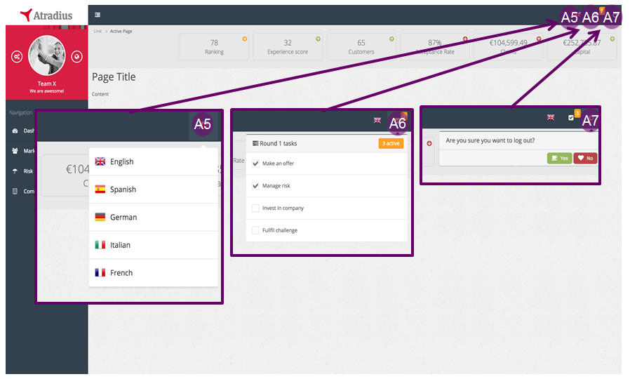
ID# | Dynamic/Static | Element Name | Element Type | Default state | Action | Response/ Notes
Block A – short description
A5 | Dynamic | languageSettings | Hyperlink | Disabled | Navbar dropdown opens languages dialog | Selected language is not in the dropdown. All content need to be ready for localization
A6 | Dynamic | activityList | Hyperlink | Disabled | Navbar dropdown opens activity list | User can not interact with the items in the activity list. The list is a fixed set of actions that the user have to accomplish in the respective round. Each round the activity list resets  Has icon notification, showing the amount of outstanding activities left undone (unchecked)
A7 | Dynamic | logoutDecision | Hyperlink | Disabled | Navbar dropdown opens logout dialog | The user can select ‘yes’ (to log user out of its session) or ‘no’ to cancel the dialog. If ‘no’ is selected, dialog box gets disabled (disappears)

ID# | Event | Business logic
A5 | OnClick & ‘language selection’ | Switch localization to the user’s selection which changes the entire text to the specific language and updates the respective page (replacing previous text with new text)
A6 | OnClick & ‘activity list dropdown’ | Dropdown the activity list with all activities displayed for each round. The activities that are outstanding are determined by whether certain actions haven’t happened yet. With every new round, set below elements to false (unchecked) and then set it to true every time an activity takes place (so it will be left as checked).  - Manage risk -> check if team has set a risk strategy on the Risk Page  - Make an offer -> check if team has made an offer on the Market Page  - Invest in company -> check if team has made an investment on the Company Page  - Fulfil challenge -> check if team has accomplished this round’s challenge (TBD)
A7 | OnClick & ‘yes’ | Log user out of its session
A8 | Load ranking number | After every round’s recalculation, teams need to be assigned a rank in comparison with other teams based on how much capital they own (i.e. team with highest capital is ranked 1). On page load – except login & error pages – current & previous round’s team rank is retrieved to display the rank and whether to display and up, right or down coloured icon.
A9 | Team’s experience level | After every round’s recalculation, all the action taken within the previous round will be translated to an experience level. See company screen details.
A10 | Number of customers | The number of current customers in their customer portfolio from previous round. If a team manages out a customer or they have gained a new customer, then in the next round this indicator will display an updated number of current customers. I suggest, during round recalculation, count the number of customers after having processed the 'managed out' and 'new customers' and store the number seperately.
A11 | Premium (not Acceptance Rate) | Instead of average Acceptance rate, we’ll show the premium earned (total of earned profit or loss from last round)
A12 | Claims amount | Total amount of claims received in previous round
A13 | Capital | Total capital position from previous round

Warnings and Exceptions
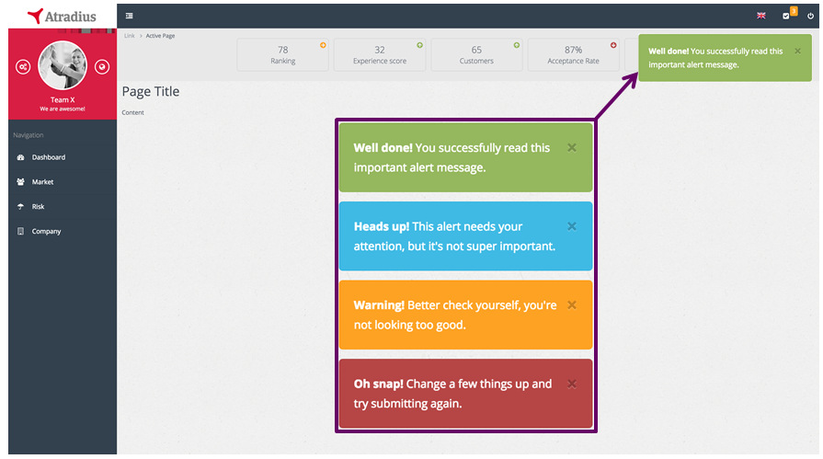

ID# | Dynamic/Static | Element Name | Element Type | Default state | Action | Response/ Notes
Alerts – alert notifications that will be defined in each screen
Alert | Dynamic | notifyer | Div tag | Disabled | Only pops up when the system pushes a message to the client (e.g. when user accomplished a specific activity)  If multiple messages have been pushed from the server, then the message will stack on top of each other with the newest on top | We used ‘toastr’ package that can easily be incorporated when certain conditions apply (front-end rendering comes included). These messages need to be localized  Implementation:  toastr.success(‘title’, ‘msg’);  toastr.info(‘title’, ‘msg’);  toastr.error(‘title’, ‘msg’);  Package:  https://github.com/Foxandxss/angular-toastr

Issues
Todo: Breadcrumb, Title/Slogan & Sidebar navigation

Login screen

Description
This screen only displays login credentials (email, password) and a button to login. The colouring is not so important yet but you can use #DC0028. Later on we can provide the exact CSS styles

Screen Layout
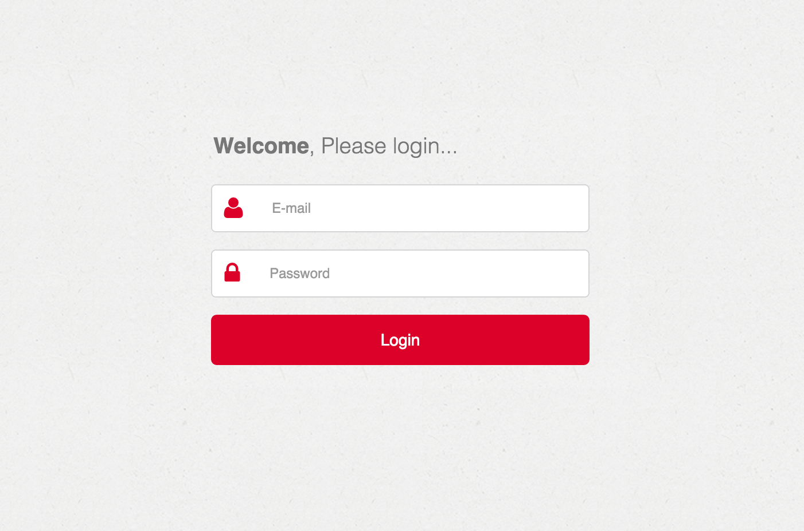

Screen Element Specification
ID# | Dynamic/Static | Element Name | Element Type | Default state | Action | Response/ Notes
Block A – short description
A1 | Dynamic | email address | Input | Active
A2 | Dynamic | Password | Input | Disabled

Validation, Business Rules, Dynamic Specifications
ID# | Event | Business logic
A1 | Username not recognized | Display inline error in red text below the button
A2 | Password not matching account | Display inline error in red text below the button

Warnings and Exceptions
…

Risk screen

Description
This screen displays the risk strategies that the team has set up. Initially this will be unpopulated, until teams create strategies, which they do by clicking on the button ‘Add New Strategy’. When they do this, a modal popup appears for them to enter the details of the strategy. Once they have created these details, the table is populated with the strategy. They also have the ability to modify or delete already existing strategies.

Proposed table for different risk scores related to symbol. To be confirmed by Jon.
1-30( Very Bad) - wi-storm-showers
31-40(Bad) - wi-cloudy
41-50(Moderate) - wi-cloud
51-60(good) - wi-day-cloudy
60+ (excellent) - wi-day-sunny

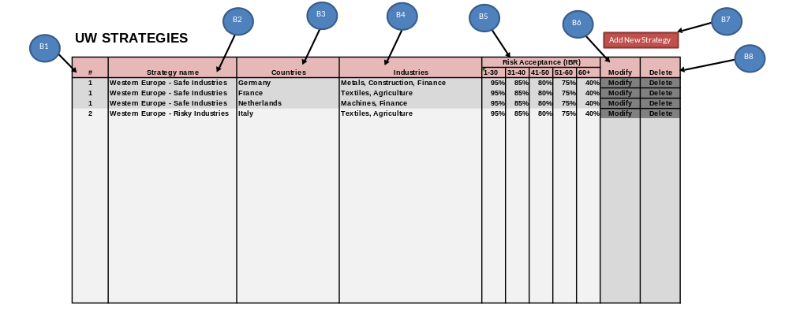
Screen Layout

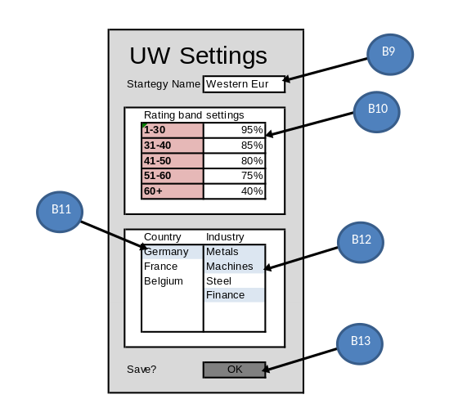

Page Invocation:

Screen | Action
UW Strategies | Click on “Risk” on sidebar. Main screen area changes to the Risk HTML.
UW Settings | Click on “Add new strategy”. Modal popup with strategy input fields appears.

Page Authorization:

User/Group | Authorization
Everyone | Full

Screen Element Specification
Ele ID# | Dynamic/Static | Element Name | Element Type | Default State | Action | Response/ Notes
UW Strategies Screen
B1 | Dynamic | ID | Table data | Shows strategy number | is always refreshed with current data | unique id
B2 | Dynamic | Strategy name | Table data | Shows strategy name | is always refreshed with current data
B3 | Dynamic | Countries | Table data | Shows strategy country | is always refreshed with current data
B4 | Dynamic | Industries | Table data | Shows strategy industries of the country | is always refreshed with current data
B5 | Dynamic | Risk Acceptance | Table data | Shows risk acceptance settings | is always refreshed with current data
B6 | Dynamic | Modify strategy | Button | Visible/Clickable | Opens uw strategy screen with data for selected strategy | user can modify strategy
B7 | Dynamic | Add strategy | Button | Visible/Clickable | Opens uw strategy screen with empty data fields | user can add strategy
B8 | Dynamic | Delete strategy | Button | Visible/Clickable | Removes Strategy | should be a confirmation box popup

Ele ID# | Dynamic/Static | Element Name | Element Type | Default State | Action | Response/ Notes
UW Settings popup
B9 | Dynamic | Strategy name input | User input | if new strategy then null, if modify then prefilled | Enter text | This is just so the user can give a name to a strategy
B10 | Dynamic | Risk Acceptance input | User input | if new strategy then null, if modify then prefilled | Enter risk acceptance rate
B11 | Dynamic | Country selection | List box | unselected if new, if modify then preselected | on click - select/unselect
B12 | Dynamic | Industry selection | List box | unselected if new, if modify then preselected | on click - select/unselect | industries are those connected to country
B13 | Dynamic | Save | Button | Visible/Clickable | saves data for strategy

Validation, Business Rules, Dynamic Specifications
Screen Element ID | Screen Name | Field level  Validations | Business Rule, Dynamic Specification
B1 | Strategy ID |  | Background colour two tone, to help separate strategies visually.
B2 | Strategy name
B3 | Countries
B4 | Industries
B5 | Risk Acceptance
B6 | Modify strategy
B7 | Add strategy
B8 | Delete strategy | Confirmation required
B9 | Strategy name input | Limited to 30 char
B10 | Risk Acceptance input | Must be percentage 0-100
B11 | Country selection | List box with options. | Countries grouped by regions.  Single selection to start (possibly find solution to make multi select).
B12 | Industry selection | List box with options | Industries of countries without a strategy available. Country-Industry combinations with strategy already show greyed out  Multi-selection
B13 | Save | Confirmation required

Tab Order
# | Element/ID (From) | Element/ID (To)
 | A7 | A7

Pop Ups
# | Element ID | Action | Pop Up Information

Pull Downs
# | Element ID | Pull down Options | Source Table/Listing

Warnings and Exceptions

Element Id | Scenario | Message Text/Box | Error/ Warning/  Information | Message Text | Existing/  New

Issues
Issue# | Issue | Resolution

Ranking screen

Description
This section details the ranking screen. This screen is comprised of four tables. The two left tables show the overall ranking, first by capital, and then by experience score. The two right tables show the ranking within the team’s country. In the example shown below, this is NL. The same tables are shown as for the overall ranking, with the exception of the country field. The ranking is not a full ranking, only a snapshot of their section of the ranking along with two teams above and below.

Screen Layout
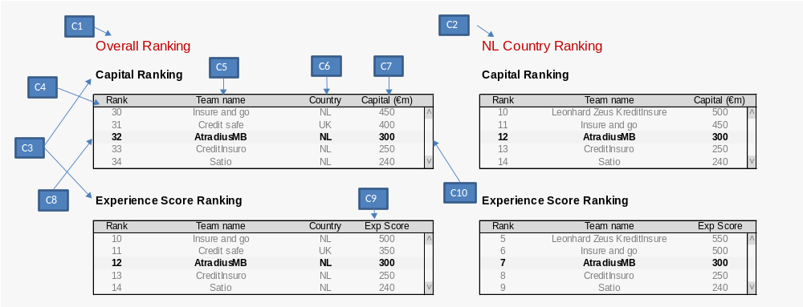

Screen Element Specification
Ele ID# | Dynamic/Static | Element Name | Element Type | Default State | Action | Response/ Notes
Ranking Screen
C1 | Static | Overall Heading | Label | “Overall Ranking” | None
C2 | Dynamic | Country Heading | Label | [Country Name] & “ Country Ranking” | None | Text varies depending on country of team.
C3 | Static | Table Heading | Label | Contains title of table | None
C4 | Dynamic | Rank field | Table field | Displays rank of team | None
C5 | Dynamic | Team name field | Table field | Displays name of team | None
C6 | Dynamic | Country field | Table field | Displays country of team | None
C7 | Dynamic | Capital field | Table field | Displays capital of team | None
C8 | Dynamic | Teams own row | Table row | This row is the details of the team that is logged in. It is bolder than the other teams in the table | Takes user to team dashboard
C9 | Dynamic | ExpScore field | Table field | Displays ExpScore of team | On mouse over, displays caption explaining what this score is.
C10 | Dynamic | Table Scrollbar | Scrollbar | As required to focus on team | Scrolls

Validation, Business Rules, Dynamic Specifications

Tab Order

Pop Ups

Pull Downs

Warnings and Exceptions

Issues

Company screen

Description
This section details the company page. This is where the teams manage the administration of their company. Thus they determine which projects are in the pipeline for the coming round, how large each department should be, and monitor their P&L. It comprises three sections (as different tabs). All of these are outlined below.

Screen Layout
Tab: Projects
D4
D5
D1
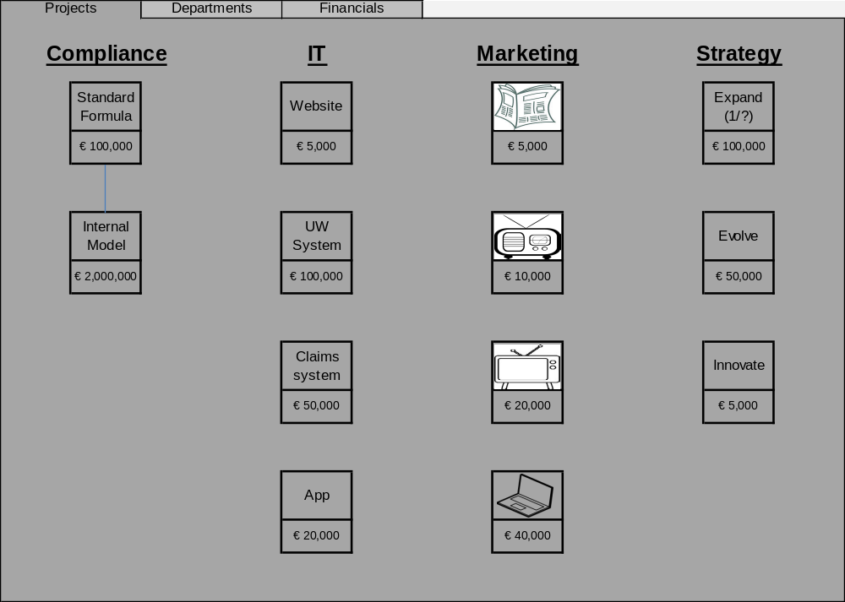
D2

D3

Tab: Departments
D7

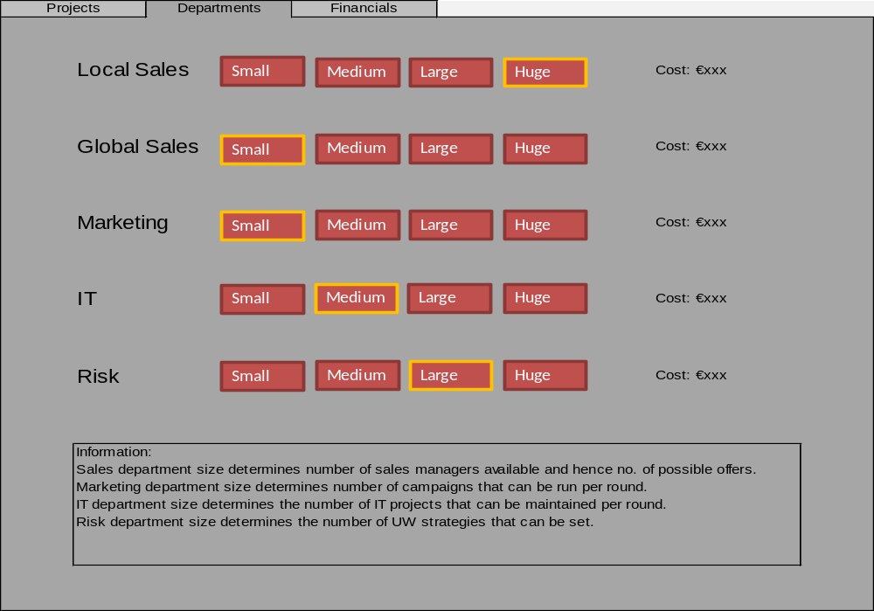
D6

D8

D9

Tab: Financials

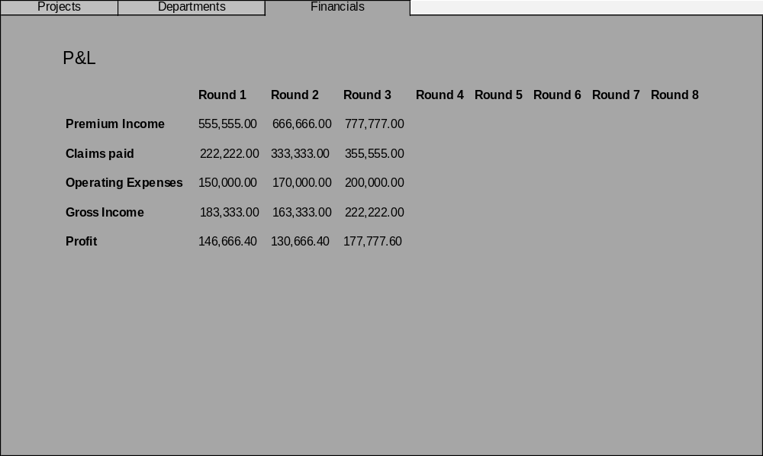
D10
D11

D12
D13
D14

D15
D16
D17

Screen Element Specification
Ele ID# | Dynamic/Static | Element Name | Element Type | Default State | Action | Response/ Notes
Company Screen
D1 | Dynamic | Company tabs | Tab | Projects tab focused | On click: select tab
D2 | Static | Project headings | Text | n/a
D3 | Static | Project link line | Line | n/a |  | Signals the required order of project implementation
D4 | Dynamic | Project icon | Icon | Greyed out | On click: deduct cost of project from team’s capital, then highlight the project box in orange and icon becomes coloured.
D5 | Dynamic | Project cost | Box with text | Default cost shown | Cost increases if the project is clicked more than once (e.g. geographic expansion ‘Expand’ )
D6 | Static | Department heading | Text
D7 | Dynamic | Department size | Button | Small is by default selected for all departments | When selected that department’s size is changed, incurring a cost for changing it ‘recruitment costs’ or ‘redundancy costs’. The active size is highlighted (e.g. in orange).
D8 | Dynamic | Department cost | Text | Cost associated with selected size (default would be that corresponding to small size department) |  | Higher costs for larger departments. Cost has two components: per round cost, and one-time cost in the event of a change in size (recruitment/redundancy)
D9 | Static | Info box | Text box | Displays text to explain the page to the user
D10 | Static | P&L Heading | Text | “P&L”
D11 | Static | Table column headings | Table column heading | Shows the rounds
D12 | Dynamic | Table row headings | Table row heading | Shows the accounting sections | On click it shows more details. (to be detailed)
D13 | Dynamic | Premium income value | Table value | Shows the premium income for the relevant round
D14 | Dynamic | Claims paid value | Table value | Shows the claims paid for the relevant round
D15 | Dynamic | Operating Expenses | Table value | Shows the costs of projects and departments.
D16 | Dynamic | Gross Income | Table value | Premium – Claims – Operating Expenses
D17 | Dynamic | Profit | Table value | Profit after tax of 20%

Validation, Business Rules, Dynamic Specifications

Tab Order

Pop Ups

Pull Downs

Warnings and Exceptions

Issues

Market screen

Description
This section details the market page. This is where the teams potentially gain new customers (in the following round) by placing offers on customers. The page is divided by three sections (tabs); ‘Local’, ‘Global’, ‘Offers’. In the first two the teams can bring out offers to companies that are in the ‘market’. The offers will be taking into the engine calculation to calculate which offer per company was best ranked. After making an offer, the offer will simply be stored and shown in the Local or Global tables. In subsequent round – after engine calculation – the offer table in the Offer tab will be updated in case the company had made the best offer.
Tip: Use angular ‘datatables’ plugin for tables, it includes a prepacked feature set to filter on search, filter on entry display and pagination. It also includes a simple api to adjust default options. See example in prototype. There are other packages out there, but this seemed to be all comprehensive and simple to use.
Tip: Use angular’s $modal to setup a popup to easily ship scope (with data) to the popup window. See example in prototype. There are other packages that may be simpler, but I am inclined to use as much native angular features as possible. However, there are some good alternative packages out there, google it.
Note: You can find the dummy data in the seed.js
Note: Version 0.6 describes only the ‘Global’ tab.

Screen Layout

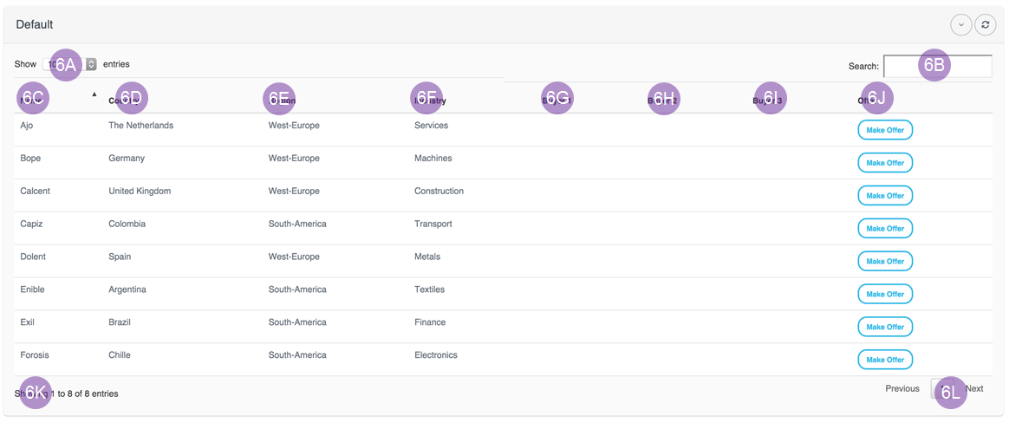

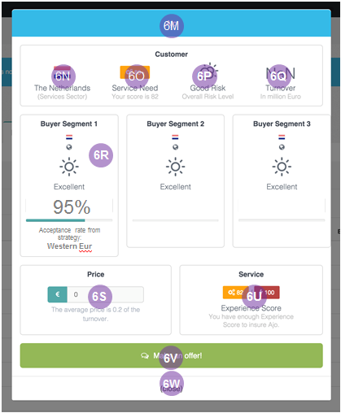

Page Invocation:

Screen | Action
UW Strategies | Click on “Market” on sidebar.

Page Authorization:

User/Group | Authorization
Everyone | Full

Screen Element Specification
Ele ID# | Dynamic/Static | Element Name | Element Type | Default State | Action | Response/ Notes
UW Strategies Screen
6A | Dynamic |  | Table options | 10 entries | Change options 10, 25, 50, 100 entries | Client side operation
6B | Dynamic |  | Search function | Empty | Filter loaded data | Client side operation
6C | Dynamic | Name | Column name | Filterable (selected) | Filter by name | Client side operation
6D | Dynamic | Country | Column name | Filterable | Filter by country | Client side operation
6E | Dynamic | Region | Column name | Filterable | Filter by region | Client side operation
6F | Dynamic | Industry | Column name | Filterable | Filter by industry | Client side operation
6G | Static | Buyer segment 1 | Column name | - | -
6H | Static | Buyer segment 2 | Column name | - | -
6I | Static | Buyer segment 3 | Column name | - | -
6J | Static | Offer | Column name
6K | Dynamic | showEntries | Column footer info (left) | 10 of n | - | Client side operation
6L | Dynamic | pagination | Column footer option (right) | Page 1 | Go to page/next slice of data based on table options settings (6A) | Client side operation
6M | Static | Customer name | Heading | - | -
6N | Static | Country/industry | HTML (flag plus title) | - | -
6O | Dynamic | Required service level | HTML (labels) | - | - | It will be predetermined when we deliver the customers seed
6P | Static | Risk score (symbol) | HTML (weather symbol plus title) | - | -
6Q | Static | Turnover | HTML block | - | -
6R | Dynamic | Buyer Segment 1 | HTML block | Get segment’s country, industry, acceptance rate and strategy name (from risk strategy based on country, industry) | On click -> go to risk page
6R | Dynamic | Buyer Segment 2 | HTML block | Get segment’s country, industry, acceptance rate and strategy name (from risk strategy based on country, industry) | On click -> go to risk page
6R | Dynamic | Buyer Segment 3 | HTML block | Get segment’s country, industry, acceptance rate and strategy name (from risk strategy based on country, industry) | On click -> go to risk page
6S | Dynamic | Price | Input | Empty | - | Input should be a number (might become two different input boxes)
6U | Static | Experience level | HTML block | - | - | Since the experience level is dynamic (it can be accumulated in various ways) we should probably not put a ceiling (100). Let's just display the one label with a dynamic number (the team's current experience level). Technically it is the same number that is below the 6O text in gray. And that is OK. In terms of determining what is enough is simply when rendering the popup with offer section (when clicking on 'make offer'), then validate if the team has an experience level equal or above the 'needed' experience level that is shown in 6O.
6V | Dynamic | Make an offer | Button | - | Close popup (and update table)
6W | Dynamic | (close) | Button | - | Close popup (no table update needed)

Validation, Business Rules, Dynamic Specifications
Screen Element ID | Screen Name | Field level  Validations | Business Rule, Dynamic Specification
6G | Buyer segment 1
6H | Buyer segment 2
6I | Buyer segment 3
6J | Offer
6M | Customer name
6N | Country/industry
6O | Required service level
6P | Risk score (symbol)
6Q | Turnover
6R | Buyer Segment 1
6R | Buyer Segment 2
6R | Buyer Segment 3
6S | Price |  | Two input fields doesn't make sense from a UX perspective. Just validate input to only allow dot notation (as a decimal seperator) and at the backend simply split by dot if having a whole number and decimal value seperate is really necessary. In grey text below the input show the percentage point relative to the total revenue (price / turnover).
6U | Experience level
6V | Make an offer

Tab Order
# | Element/ID (From) | Element/ID (To)
 | A7 | A7

Pop Ups
# | Element ID | Action | Pop Up Information

Pull Downs
# | Element ID | Pull down Options | Source Table/Listing

Warnings and Exceptions

Element Id | Scenario | Message Text/Box | Error/ Warning/  Information | Message Text | Existing/  New

Issues
Issue# | Issue | Resolution

Appendix

